CS 250 Spring 2017 - Lab 03

Due in lab Feb. 07-10, 2017

Submit your typewritten file in PDF format to Blackboard

**Questions**

1. [15 points; 5 points for each for result] Does the timing of the 555 clock output match the predictions of the equations for frequency, t_high, and t_low that are given below the schematic? Show a calculation of the expected value for each of the three parameters.. $$f=\frac{1}{\ln\left(2\right)∙C2∙(R1+2∙R2)};t_{low}=\ln\left(2\right)∙R2∙C2;t_{high}=ln⁡(2)∙(R1+R2)∙C2$$
$$C2=1000μF (0.001F);R1=470Ω;R2=470Ω$$

$$f=\frac{1}{\ln\left(2\right)∙0.001∙(1410)}=\frac{1}{0.977338}=1.023Hz≈1Hz$$

$$t_{low}=\ln\left(2\right)∙470∙0.001=0.325779s$$

$$t_{high}=\ln\left(2\right)∙\left(940\right)∙0.001=0.651558s$$

2. [10 points] The 74HC163 is a 4-bit counter, but this lab needs only a 3-bit counter. How can you obtain a 3-bit counter from the output of a 4-bit counter? Which three of the output signals would you select and why?  
     
   The 163N uses QA as the LSB and QD as the MSB, so we can shift down to get a 3-bit counter instead of 4-bit. So use QA as LSB, QC as MSB, and QB. You would also need to clear when QA, QB, QC are active.
3. Derive the Boolean expressions for each color of the stoplight, and simplify in terms of 2-input NAND and NOR gates. Show your work to earn credit. Your Boolean expression must be in terms of QA, QB, QC, and QD, for the counter outputs, and/or D0 – D7 for the eight decoder/demux outputs. Draw the final schematic diagram using NAND and NOR gates for each color.
   1. [10 points] Green light Boolean expression and schematic.

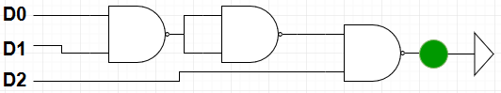

* 1. [10 points] Yellow light Boolean expression and schematic.



* 1. [10 points] Red light Boolean expression and schematic drawing of gates.

$$\overline{\left(D4∙D5∙D6∙D7\right)}$$ 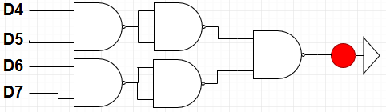

1. Demonstrate your circuit to your TA. Full credit when the order and timing of lights is correct.
   1. [15 points] Green light turns on for 3 seconds, then
   2. [15 points] Yellow light turns on for 1 second, then
   3. [15 points] Red light turns on for 4 seconds.